Related Work
S.No | Year | Authors | Dataset | Modality | Methodology/Model Used | Accuracy
1 | 2025 | A. Rani Palakayala, P. Kuppusamy, D. Kothandaraman, G. Archana and J. Gera | PPMI | MRI, Gait measurements, and speech | Hierarchical Attention-based Multi-modal Fusion (HAMF) with GA-PSO, TCN, and DANN for multi-modal PD diagnosis and severity estimation | 94.2

References
- A. Rani Palakayala, P. Kuppusamy, D. Kothandaraman, G. Archana and J. Gera, "HAMF: A Novel Hierarchical Attention-Based Multi-Modal Fusion Model for Parkinson’s Disease Classification and Severity Prediction," in IEEE Access, vol. 13, pp. 81252-81278, 2025, doi: 10.1109/ACCESS.2025.3563177.

Cite all papers (Steps)- IEEE publisher


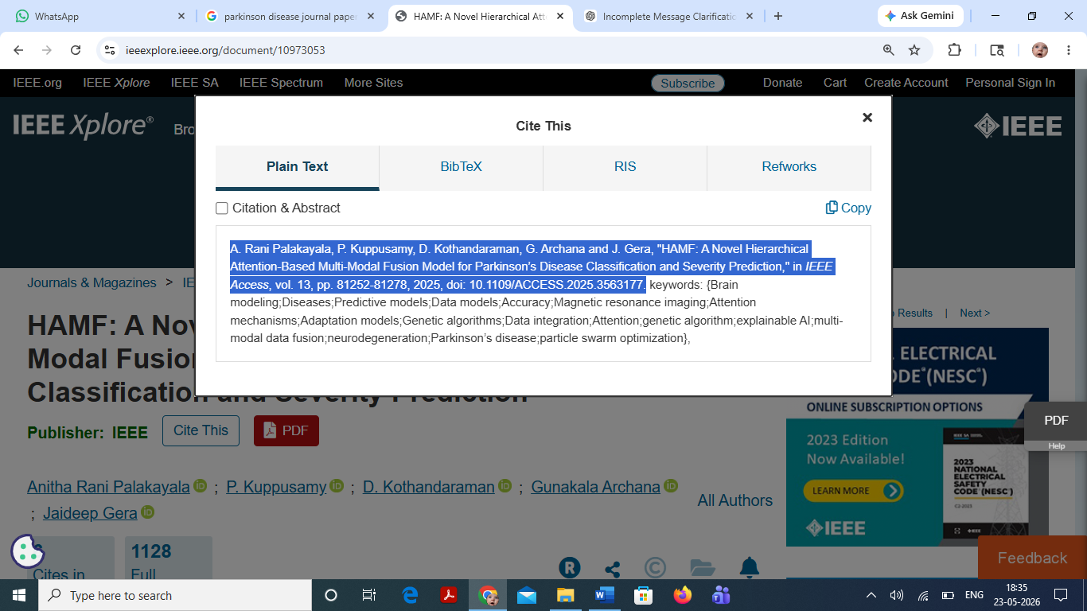
Cite all papers (Steps)- Springer publisher
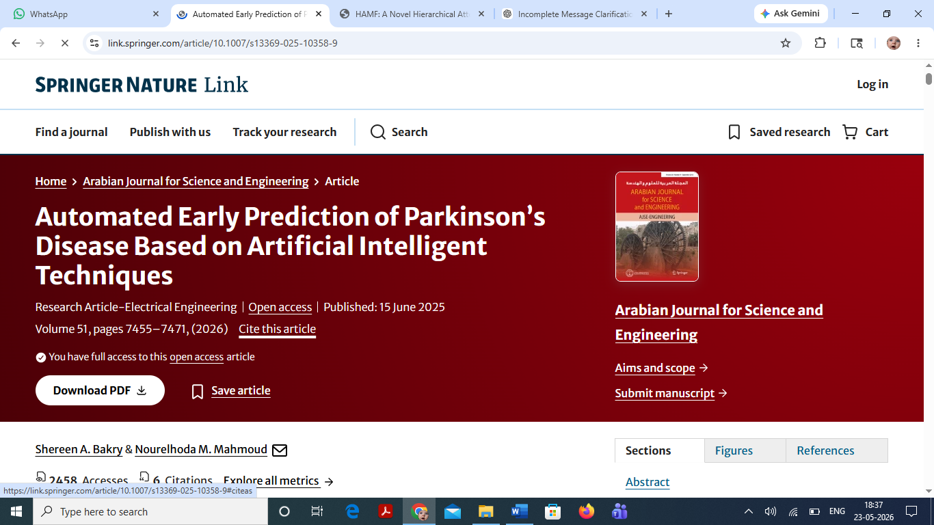

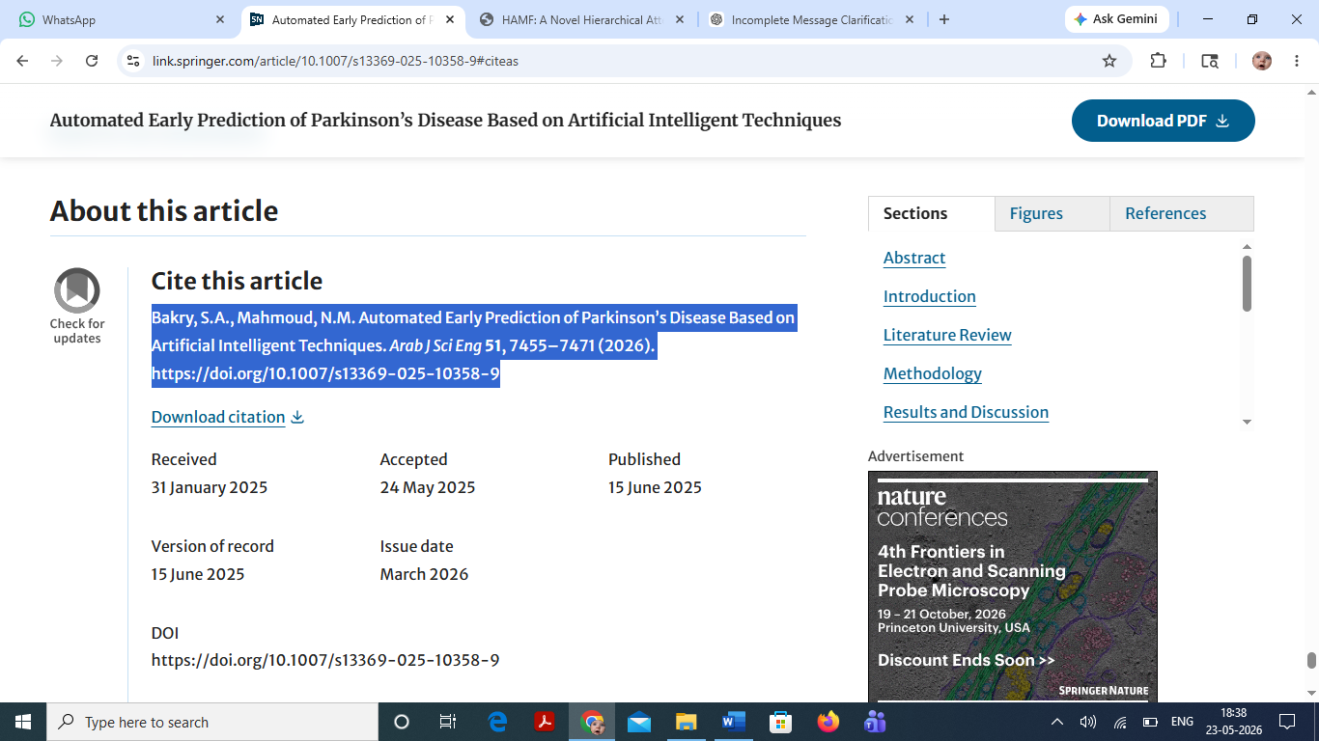

Cite all papers (Steps)- Elsevier publisher
